Exploratory Data Analysis (EDA) Report
1. Introduction

Exploratory Data Analysis (EDA) was conducted on the processed dataset to understand the distribution, relationships, and characteristics of the sensor data collected from the smart plant monitoring system. The dataset includes the following features:

Plant type
Soil moisture percentage (soil_pct)
Temperature
Humidity
Light intensity

The purpose of this analysis is to validate data quality, understand patterns, and ensure suitability for machine learning model training.

2. Soil Moisture Distribution

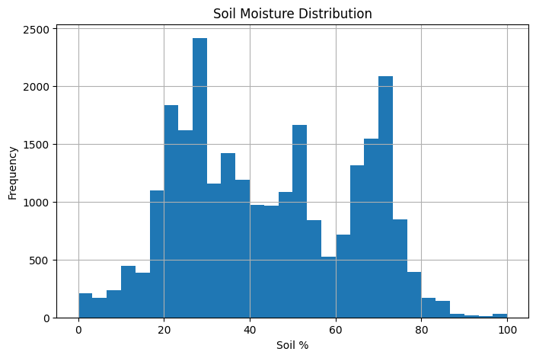

The soil moisture distribution graph shows how soil moisture values are spread across the dataset.

Observations:
Soil moisture values range approximately from 0% to 100%, which is expected.
The distribution is well spread, with multiple peaks around:
20–40% (dry to moderate soil)
60–75% (moist soil)
There is no extreme clustering at a single value.
Conclusion:

The dataset contains a balanced representation of dry, moderate, and wet soil conditions, which is ideal for training a classification model to detect watering needs.

3. Soil Moisture per Plant Type
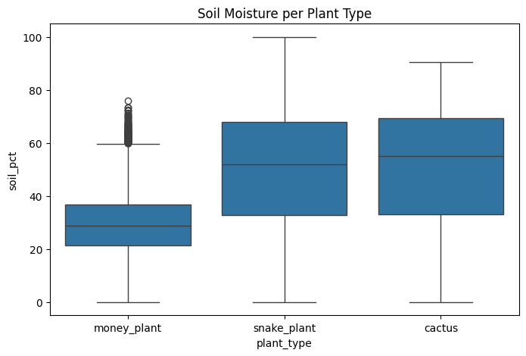

A boxplot was used to compare soil moisture across different plant types.

Observations:
Money Plant:
Lower median soil moisture (~25–30%)
Narrower spread
Snake Plant:
Moderate median (~50%)
Wider variability
Cactus:
Slightly higher median (~55%)
Wide spread similar to snake plant
Key Insight:
Different plant types show distinct moisture distributions, confirming that:
Each plant has different watering behavior
Plant-specific thresholds are necessary

Conclusion:
This validates the decision to use plant-specific thresholds when defining water_needed.

4. Temperature Distribution

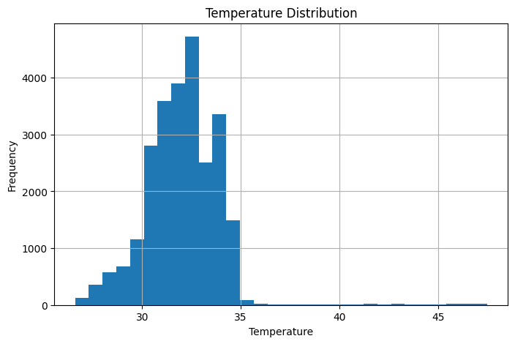
Observations:
Most temperature values lie between 28°C and 35°C
Very few extreme values above 40°C
Distribution is approximately normal
Conclusion:
The temperature data is realistic and consistent with indoor conditions, making it a reliable feature for the ML model.

5. Humidity Distribution

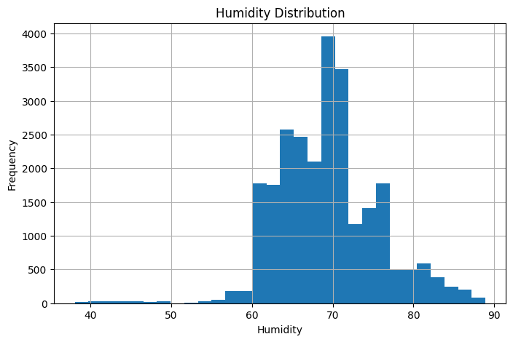
Observations:
Humidity values mostly fall between 60% and 75%
Some values extend up to ~85–90%
Distribution is slightly skewed but still reasonable
Conclusion:

Humidity values are within a normal indoor range, and no abnormal spikes are observed.

6. Feature Correlation Analysis

A correlation heatmap was used to understand relationships between variables.

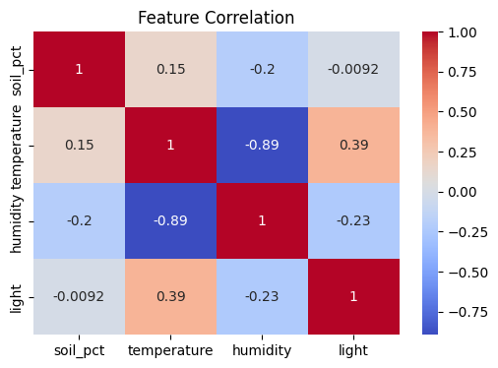

Observations:
Temperature vs Humidity:
Strong negative correlation (-0.89)
As temperature increases, humidity decreases
Temperature vs Light:
Moderate positive correlation (~0.39)
Soil Moisture vs Other Features:
Weak correlations:
soil vs temp (~0.15)
soil vs humidity (~-0.20)
soil vs light (~0)
Conclusion:
Soil moisture is largely independent, which is good
Other environmental variables may still contribute to prediction but are not dominant

Plant-wise Label Distribution

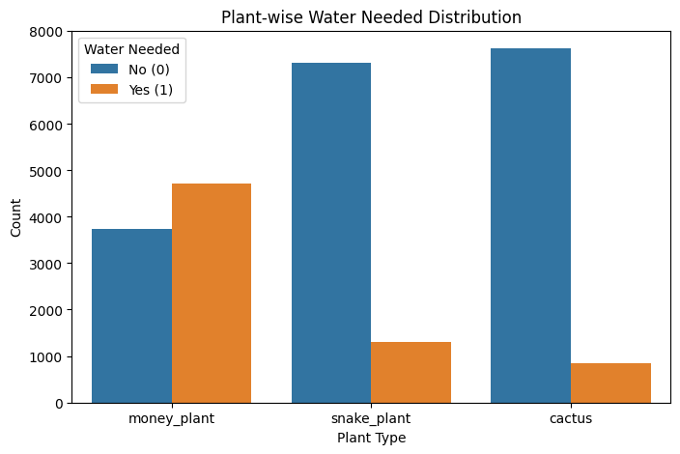

The distribution of water_needed was further analyzed across different plant types.

Interpretation of Plant-wise Behavior
Cactus:
Water required in only ~10% of cases
Indicates strong drought tolerance
This aligns with real-world behavior, where cactus plants require minimal watering.

Money Plant:
Water required in ~56% of cases
Shows frequent need for moisture
This reflects the plant’s preference for consistently moist soil conditions.

Snake Plant:
Water required in ~15% of cases
Moderate watering frequency
This matches its semi-drought-tolerant nature.

